Nonfunctional Requirement

Intellij IDEA 2018

JDK 8

Downloads:

1)Download Intellij IDEA 2018 from

<https://www.jetbrains.com/student/>

2)Download JDK 8 from

<https://www.oracle.com/technetwork/java/javase/downloads/jdk8-downloads-2133151.html>

3)Download the repository from below link. <https://github.com/ChrisSchaffer/cs414-f18-001-stringCheese>

Environment Setup

IntelliJ

1. Double click and install Intellij.
2. Add Junit, GitHub plugins in installation time.
3. Restart the Intellij.
4. Go to File->Open->”select the your folder where you download GitHub repo”
5. Go to File->Project Structure(ctr+shift+alt+s)->Project SDK->click New->select path till JDK folder from computer.

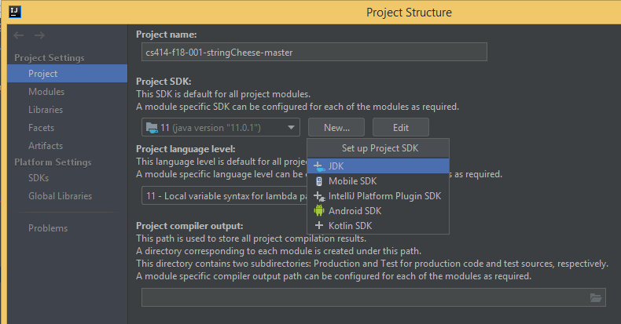

JDK-8

1)Double click on setup that you download.

2)Check JAVA:Open terminal and write “javac --version” and hit Enter

Project Structure:

1)Main package id edu/colostate/cs/cs414/StringCheese.

2)There are 2 folder src and Test.

3)src folder contain All class file and Test contain all the test file.

4) GameDriver.java contain Main method of project.

